Function Invocation

* Performed when an expression that evaluates to a function is followed by (arg1, arg2)

Simple example:

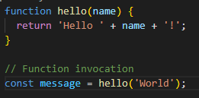

* Cannot be a property accessor
  + Leads to creating **method invocation**
    - obj.myFunc()
    - eg. [1,5].join(‘,’)

IIFE

* Immediately-Invoked Function Expression
* More advanced

